NAME:- GANESH DAMODHAR SHITOLE
ROLL NO:- 83583

Assignment no.6
1.
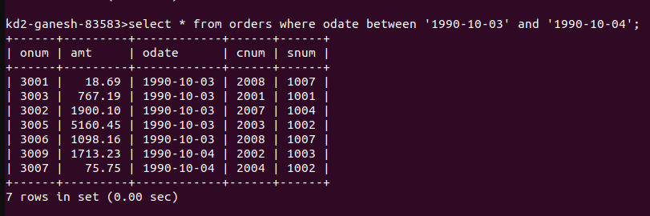

2.
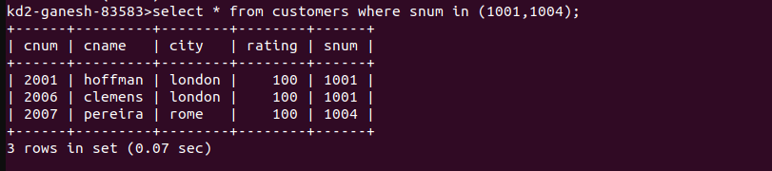
3.
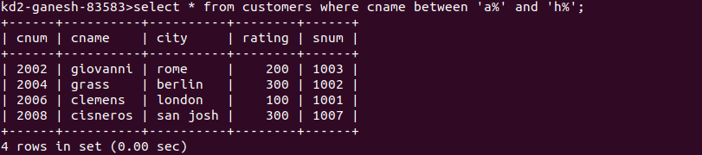
4.
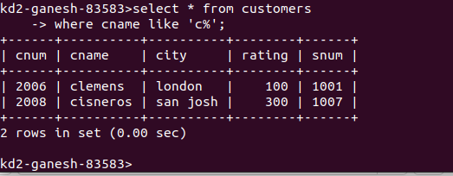

5.
